**Project Identification**

|  |  |
| --- | --- |
| **Project:** | JC Consulting |
| **Prepared By:** | Team #24 |
| **Document Version:** | 1.0 |
| **Published Date:** | Oct 10th, 2018 |

**Contributors**

The following individuals contributed to this document.

| **Name** | **Title** |
| --- | --- |
| Tam Dang | *Student* |
| Christopher Santin | *Student* |
| Quan Trinh | *Student* |

**Distribution**

This document is distributed to all the following people.

| **Name** | **Title** |
| --- | --- |
| Anjana Shah | Professor |
| Tyler Krimmel | Professor/Supervisor |
| JC Consulting | Company |
| BA Team | Students |

**Referenced Documents**

This document refers to the following materials

|  |  |  |  |  |
| --- | --- | --- | --- | --- |
| **Version number** | **Title** | **Author** | **Date** | **Source / Location** |
| 1.0 | *Project Vision* | T24 | Oct 10th, 2018 | George Brown College |
| 1.0 | *Summary Template* | T24 | Oct 10th, 2018 | George Brown College |
| 1.0 | *High Level Requirements* | T24 | Oct 10th, 2018 | George Brown College |
| 1.0 | *Project Plan* | T24 | Oct 10th, 2018 | George Brown College |

**Revision History**

|  |  |  |  |
| --- | --- | --- | --- |
| **Version Number** | **Revision Date** | **Summary of Changes** | **Modified by** |
|  |  |  |  |
|  |  |  |  |
|  |  |  |  |

[Note: It is recommended that drafts be numbered 0.1 to 0.9, and that the first approved version be numbered 1.0. Thereafter, new version numbers will depend upon changes: 1.01, 1.1, etc for minor updates, 2.0, 3.0 etc for major changes.]

TABLE OF CONTENTS

1. Business Context Diagram 3

2. REquirements Scope Statements 4

3. High Level Business Requirements (HLR) Traceability 4

4. High Level Business Requirements Sign-Off 5

1. Business Context Diagram

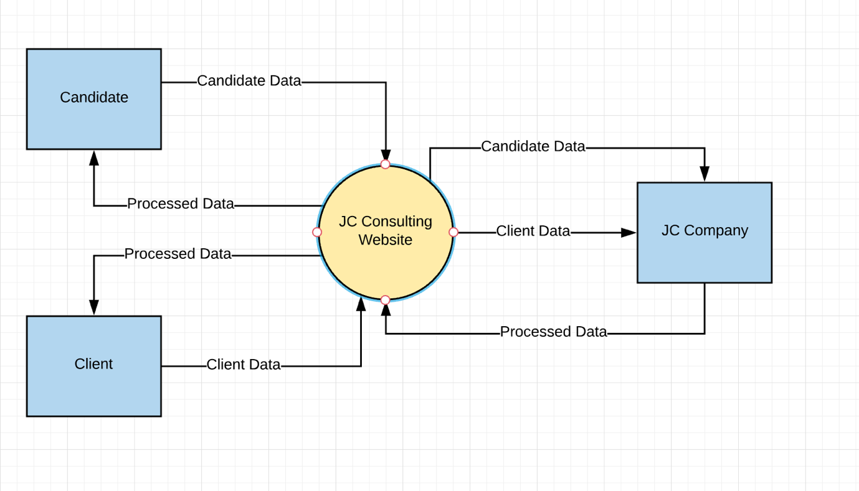

|  |  |
| --- | --- |
| **Requirement Scope Area** | **Description** |
| JC Consulting Website | Area responsible for providing storage, analysis, recommendation to users. e.g: job positions, best fit candidate etc. |

|  |  |
| --- | --- |
| **External Entity** | **Description** |
| JC Company | External area that collects user inputs, uses machine learning or other mechanisms to search for appropriate match |
| Candidate | Candidate or job seeker who can enter input, view, download or delete related data |
| Client | Client or employer who can enter input, view, download or delete related data |

| **Information Flows** | **Description** |
| --- | --- |
| Candidate Data | Any data or document in an electronic format that the candidate can upload, download, store, view or delete through JC Consulting Website. E.g. resume, work experience, skills, etc. |
| Client Data | Any data or document in an electronic format that the client can upload, download, store, view or delete through JC Consulting Website. E.g. job positions, job requirement, etc. |
| Processed Data | Data which has been analyzed and generated by JC Company. Candidate and Client can view their processed data. E.g. list of suitable jobs/candidates |

1. Requirements Scope Statements

|  |  |  |
| --- | --- | --- |
| **HLR#** | **Description** | **Priority**  **(H, M, L)** |
| HLR01 | Candidate and Client must be able to register an account for accessing to the web app | H |
| HLR02 | Candidate and Client must be able to review, modify, delete their profile and uploaded document | H |
| HLR03 | Candidate must receive notifications on their recommended jobs | M |
| HLR04 | Client must receive notifications on their prospective employee | H |
| HLR05 | JC Company must be able to access and view, download all the data | H |

1. High Level Business Requirements Sign-Off

The undersigned acknowledge their agreement with the contents of Version <x.x> of the High-Level Requirements document for <Project Name>.

Following approval of this document, requirements changes will be governed by the project’s change management process, including impact analysis and appropriate reviews and approvals, under the general control of the Project Plan and according to company policy. Approved Change Request Documents, if present, will be attached to this Requirements Document as updates.

|  |  |  |
| --- | --- | --- |
| **Name** | **Project Role and**  **Functional Area** | **Date Signed** |
| Chris Santin | Developer | Oct. 10, 2018 |
| Tam Dang | Developer | Oct. 10, 2018 |
| Quan Trinh | Developer | Oct. 10, 2018 |
| Anjana Shah | Primary Instructor |  |
| Tyler Krimmel | Project Supervisor |  |

* Note: physical signatures are not required. Email approvals are acceptable and should be appended to project documents.